________ any of a class of nitrogenous organic compounds that have large molecules composed of one or more long chains of amino acids and are an essential part of all living organisms, especially as structural components of body tissues such as muscle, hair, etc., and as enzymes and antibodies
A. Carbohydrate
B. Protein
C. Lipids
D. Nucleic acid
ANSWER: B
The element in the structure of proteins which differentiates them from carbohydrates is:
A. C
B. H
C. N
D. None of these
ANSWER: C
The name protein was suggested by:
A. Berzelius
B. Laveran
C. Hertwig
D. Singer
ANSWER: A
Proteins are composed of:
A. Monosaccharide
B. Fatty acid
C. Amino acid
D. Nucleotides
ANSWER: C
As membrane receptors and transporters, ______ determine what type of substance should enter or leave the cells
A. Proteins
B. Nucleic acids
C. Carbohydrates
D. Lipids
ANSWER: A
Amino acids are the organic compounds which contain:
A. Carboxylic group
B. One basic Amino and one acidic carboxylic group
C. Oxygen group
D. Alkyl group
ANSWER: B
The amino acid are linked together by a bond called:
A. Peptide linkage
B. Alkyl linkage
C. Tri linkage
D. Keto linkage
ANSWER: A
There are __________basic amino acids
A. 15
B. 20
C. 25
D. 30
ANSWER: B
Proteins are:
A. Monomers of amino acids
B. Trimer of amino acids
C. Polymers of amino acids
D. Dimers of amino acids
ANSWER: C
Basic group in Amino acid is:
A. Hydrogen
B. Amino group
C. Carboxylic
D. Alkyl
ANSWER: B
Acidic group in Amino acid is:
A. Hydrogen
B. Amino group
C. Carboxylic group
D. None of these
ANSWER: C
General formula of amino acid is:
A. NH2-HCR-COOH
B. HCR-NH2-COOH
C. HCR-COOH-NH2
D. H2CR-COOH-NH2
ANSWER: A
In Glycine, an amino acid R group is replaced by
A. H
B. CH3
C. COOH
D. C = O
ANSWER: A
Proteins comprise of _____% of the total dry weight of a cell.
A. 40%
B. 50%
C. 60%
D. 70%
ANSWER: B
The diagram shows a molecular structure
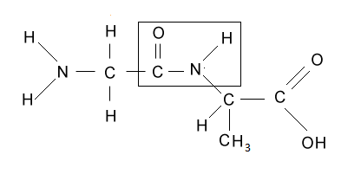
What is the structure enclosed by a box?
A. An amino acid
B. A glyosidic bond
C. A nucleotide
D. A peptide bond
ANSWER: D
An amino acid molecule has the following structure:
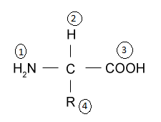

Which two of the groups combine to form a peptide link?
A. 1 and 2
B. 1 and 3
C. 2 and 3
D. 2 and 4
ANSWER: B
A __________is a short protein consisting of only two amino acids linked together by one peptide bond
A. Tripeptides
B. Polypeptides
C. Dipeptide
D. Glycosides
ANSWER: C
In the polypeptide chain, amino acids are linked together by:
A. Hydrolysis
B. Condensation process
C. Both A and B
D. None of these
ANSWER: B
The amide bond is synthesized when the carboxyl group of one amino acid molecule reacts with the amino group of the other amino acid molecule, causing the release of a molecule of:
A. Nitrogen
B. Oxygen
C. Water
D. Hydrogen
ANSWER: C
Peptides and proteins are chains of amino acids held together by
A. Glycosidic bonds
B. Peptide bonds
C. Covalent bonds
D. Ionic bonds
ANSWER: B

